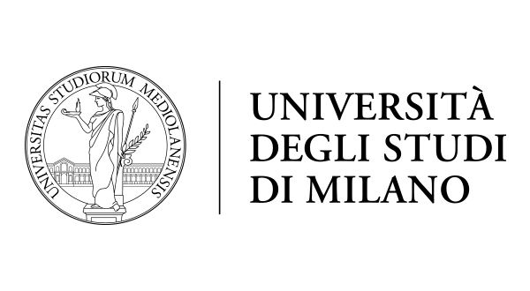

**Regional Well Being in Different Countries Over the World.**

**Course**: Advanced Multivariate Statistics

**Professor**: Andrea Cappozzo

**Students**: Akash Mittal, Maged Saeed Abdo Mostafa Kharshom, Precious Prince, Franco Reinaldo Bonifacini